**Procedural Programming Assignment No. 2B**

**Name : Tejas Waghmare**

**Roll no. : 72**

**Div : N**

**Aim :** To calculate and display the perimeter and area of a square, rectangle, and triangle based on user input.

**Algorithm:**

1. The program.
2. Declare necessary variables for side lengths and area.
3. Prompt the uStart ser to enter the length of the side of the square.
4. Read the input for the square's side.
5. Calculate the perimeter of the square using the formula 4 * side.
6. Calculate the area of the square using the formula side * side.
7. Display the perimeter and area of the square.
8. Prompt the user to enter the length and breadth of the rectangle.
9. Read the inputs for length and breadth.
10. Calculate the area of the rectangle using the formula length * breadth.
11. Calculate the perimeter of the rectangle using the formula 2 * (length + breadth).
12. Display the area and perimeter of the rectangle.
13. Prompt the user to enter the base and height of the triangle.
14. Read the inputs for base and height.
15. Calculate the area of the triangle using the formula 0.5 * base * height.
16. Display the area of the triangle.
17. Prompt the user to enter the three sides of the triangle.
18. Read the inputs for the three sides.
19. Calculate the perimeter of the triangle using the formula side1 + side2 + side3.
20. Display the perimeter of the triangle.
21. End the program.

**Pseudocode:**

BEGIN

DECLARE a, b, c, length, breadth, side, perimeter AS INTEGER DECLARE area AS FLOAT

PRINT "Enter the length of the side of the square: "

INPUT side SET area = side * side SET perimeter = 4 * side

PRINT "Area of the square: ", area

PRINT "Perimeter of the square: ", perimeter

PRINT "Enter the length of the rectangle: "

INPUT length

PRINT "Enter the breadth of the rectangle: "

INPUT breadth

SET area = length * breadth

SET perimeter = 2 * (length + breadth)

PRINT "Area of the rectangle: ", area

PRINT "Perimeter of the rectangle: ", perimeter

PRINT "Enter the three sides of the triangle: "

INPUT a, b, c

SET perimeter = a + b + c

SET s = (a + b + c) / 2

SET area = sqrt(s * (s - a) * (s - b) * (s - c))

PRINT "Perimeter of the triangle: ", perimeter

PRINT "Area of the triangle: ", area

END

**Code/Program:**

**#include<stdio.h> int main()**

**{ int side,l,b,h,base,area,side1,side2,side3;**

**//user input for length of side printf("Enter the length of side of the square:\n"); scanf("%d", &side); //Calculate Perimeter of square printf("Perimeter of square : %d\n",4*side);**

**//Calculate Area of the Square printf("Area of square : %d\n", side*side);**

**//Calculate Area & Perimeter of the Rectangle printf("Enter the length and breadth of the rectangle : \n"); scanf(" %d %d", &l,&b); printf("Area of rectangle : %d\n",l*b); printf("Perimeter of rectangle : %d\n",2*l+b);**

**//Calculate Area & Perimeter of the triangle printf("Enter the base and height of the triangle :\n"); scanf("%d %d", &base,&h); area=0.5*base*h; printf("Area of Triangle : %d\n",area); printf("Enter the three sides of the triangle : \n"); scanf("%d %d %d",&side1,&side2,&side3); printf("Perimeter of the triangle : %d\n",side1+side2+side3); return 0;**

**}**

**Output:**

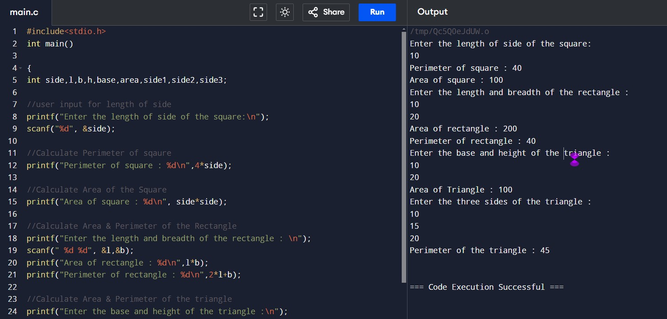

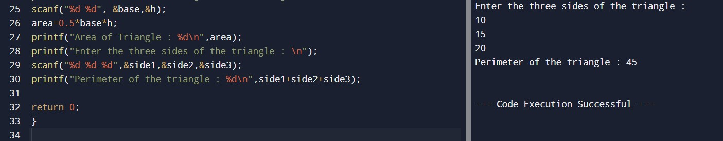

**Conclusion:**

The provided C program successfully calculates and displays the perimeter and area for three geometric shapes: a square, a rectangle, and a triangle. It prompts the user for the necessary dimensions and performs the required calculations.